Team 10's Requirements Documentation

final report

Park sung hyun 201021626 industrial engineering

Jin won jun 201122817 software

Son jea man 201420929 software

Rho geun tak 201520860 software

**the purpose and features of the application**

**=>**Elementary school children who are learning about basic programming Fun and Joy.

Some child look the programming language unfamiliar. So our team make the application, our

application make learn Programming language easily to child. also, our application contained Quiz about the Concepts, children can learn easily programming language typing practice.

-ScreenShots-

<MAIN>

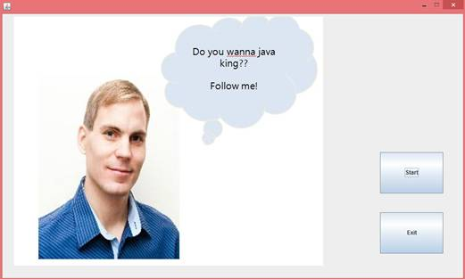

<LEVEL SELECT>

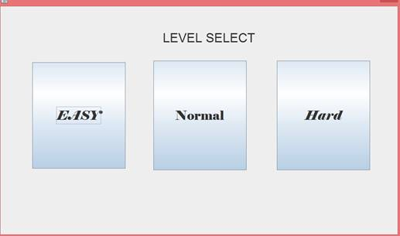

<Concept>

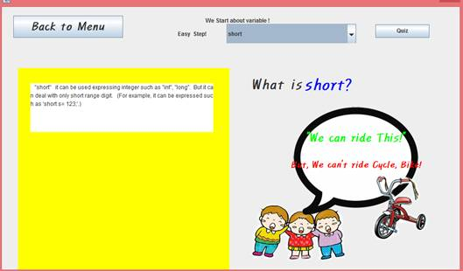

<QUIZ>

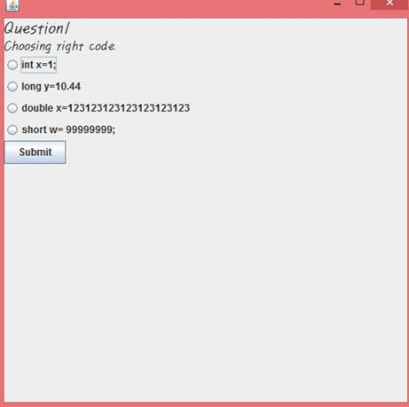

<password check>

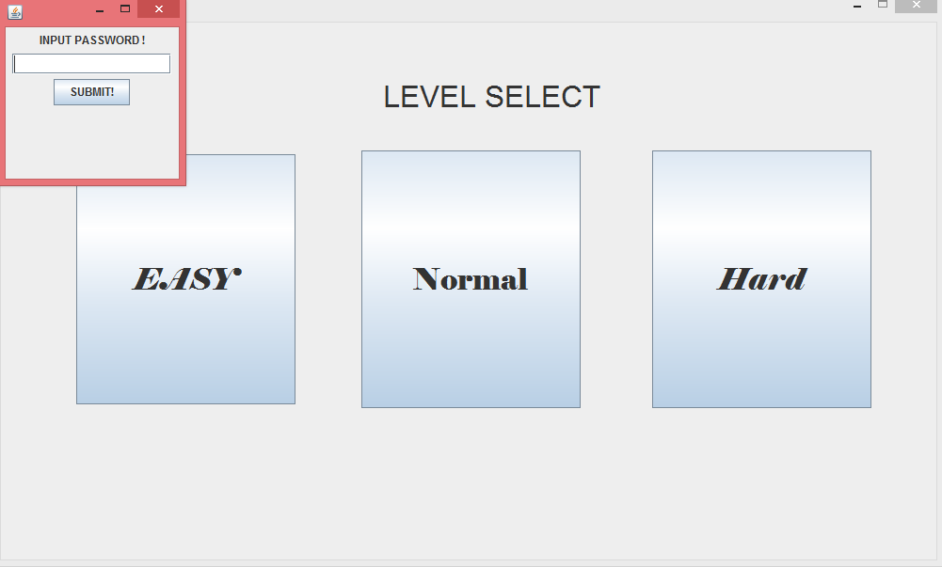

**system architecture**

< class diagram >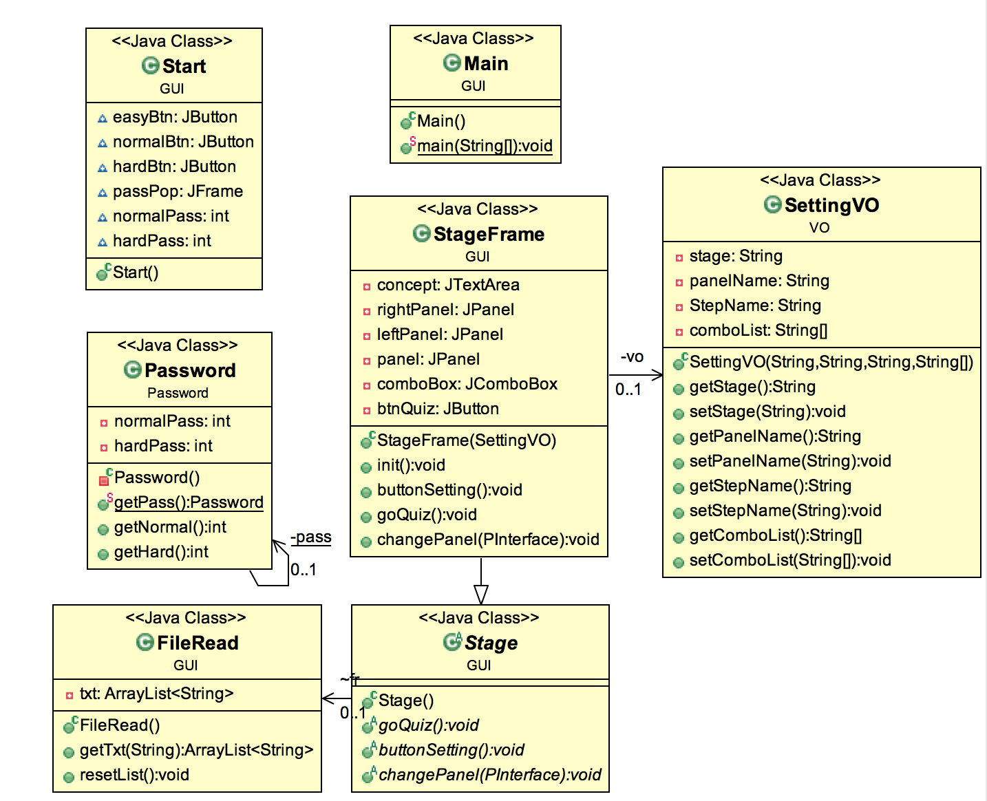

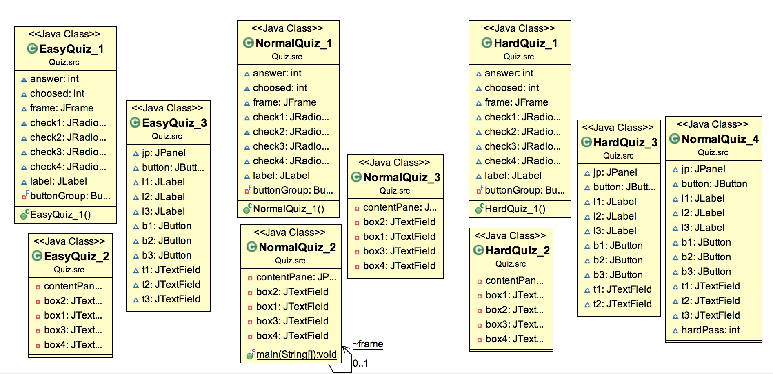

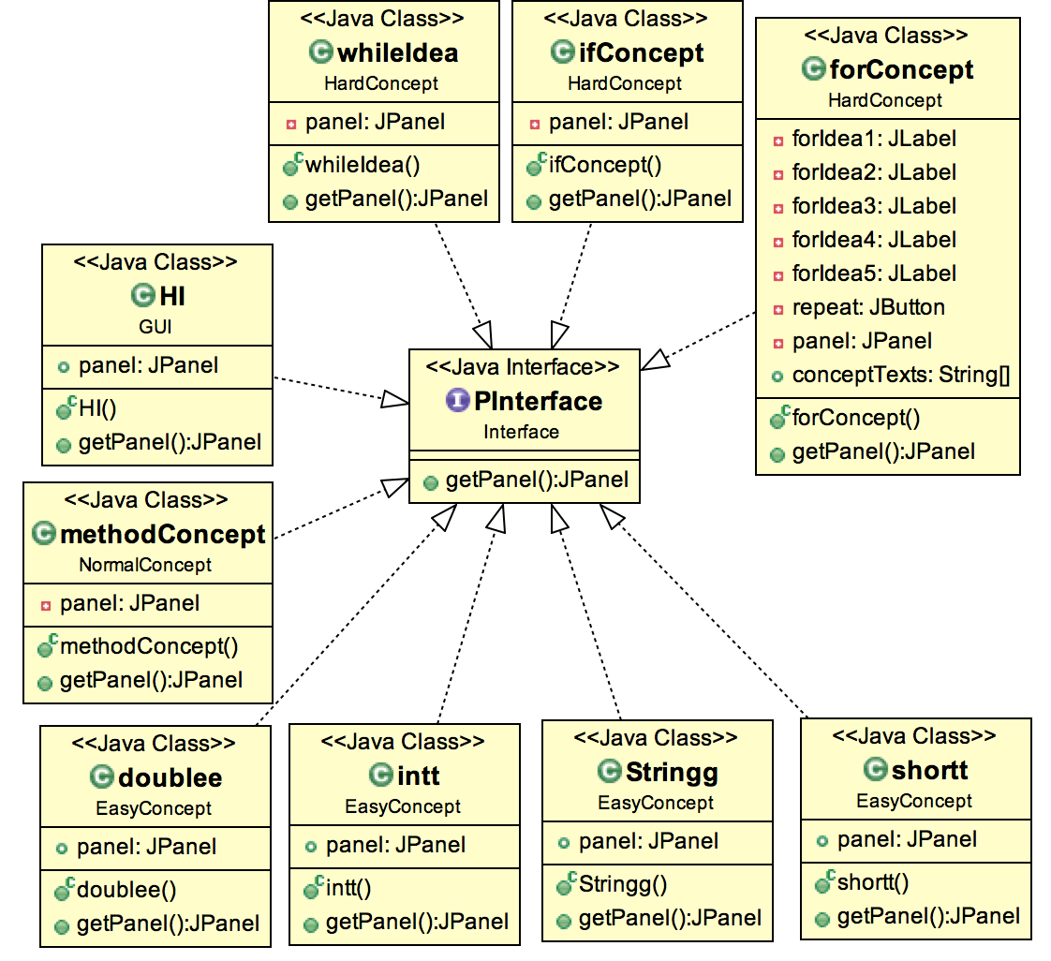

<explanation>

PInterface is a panel interface. Classes that inherited this interface must implement getPanel().

We used panel that made by inherited class as a corresponding StageFrame’s rightPanel.

In StageFrame, we used polymorphism at getPanel’s parameter, so we can change rightPanel’s value simply by classes inherited PInterface which is handled by parameters. we can realize object oriented programming by modularizing StageFrame’s content.

we used abstract class stage, so we can do maintenances easily by forcing StageFrame’s realization parts.

In StageFrame, we made EasyStage, NormalStage and HardStage’s common frame and made SettingVO object that produces elements which will be inserted in codes. By using this way,we could reduce the overlapping of codes and add new stage by modifying SettingVO object only. Also we don’t have to modify StageFrame when we do maintenances.

Other objects can’t make password, because we used Singleton pattern in password part. And we get password by using encapsulation.

we let Screen GUI inherit JFrame.

In Quiz Class, we distinguish each frame to increase cohesion and decrease coupling.

when codes combined with high cohesion, support the general goals of high readability and maintainability. So we increased cohesion.

-EasyConcept-

doublee.java - this class is about MainFrame's Right panel. when user checks comboBox 'double' ,this panel explains about double using visual contents because this inherits 'PInterface' , so implements getPanel to send panel

intt.java - this class is about MainFrame's Right panel .when user check comboBox 'int' ,this panel explains about 'int variable' using visual contents.

shortt.java - this class is about MainFrame's Right panel.when user check comboBox 'short' ,this panel explains about 'short variable' using visual contents.

Stringg.java - this class is about MainFrame's Right panel when user check comboBox 'String', this panel explains about 'short variable' using visual contents.

-NormalConcept-

methodConcept.java - this class is about methodConcept panel .

-HardConcept-

forConcept.java - this class is about ‘for’, and has visual contents which will be visualized in right panel

ifConcept.java - this class is about ‘if’, and has visual contents which will be visualized in right panel

whileConcept.java - this class is about ‘while’, and has visual contents which will be visualized in right panel

-Password-

Password.java - this class make password randomly and by using Singleton pattern, other class can't create and change password. because don't make setter.

-GUI-

FileRead.java - In this class , MainFrame leftPanel's component is made. This class reads the text file and returns text by using ArrayList<String>, and this class uses bufferedReader.

HI.java - this class is about MainFrame's Right panel. when user checks 'Choice!' which is in comboBox ,shows text which explain what users have to do.

Main.java - this class is about main Frame. user can choice 'Start' or 'Exit'.

Stage.java - this is a Interface.To compel implements about Frame and children class uses FileRead.

StageFrame.java - This class make Easy, Normal, Hard Frame by using VO class. VO Class has String stage, panelName, StepName, comboList[].

Start.java - user can choice easy level, normal level, hard level.

-Interface-

Pinterface.java - this is a interface. this returns panels.

-Quiz-

EasyQuiz_1.java - this class makes objective problem about easy part’s concepts.

EasyQuiz_2.java - this class makes order sequence problem about easy part’s concepts.

EasyQuiz_3.java - this class makes writing problem about easy part’s concepts.

NormalQuiz_1.java - this class makes objective problem about normal part’s concepts.

NormalQuiz_2.java - this class makes order sequence problem about normal part’s concepts.

NormalQuiz_3.java - this class also makes order sequence problem about normal part’s concepts.

NormalQuiz_4.java - this class makes writing problem about normal part’s concepts.

HardQuiz_1.java - this class makes objective problem about hard part’s concepts.

HardQuiz_2.java - this class makes order sequence problem about hard part’s concepts.

HardQuiz_3.java - this class makes writing problem about hard part’s concepts.

<inheritance & abstract>

we will make the new class with abstract named stage.

then we will make the easy normal hard class inherit from stage... by doing them, it could be very useful to maintenance when we handle stage class or edit the class.

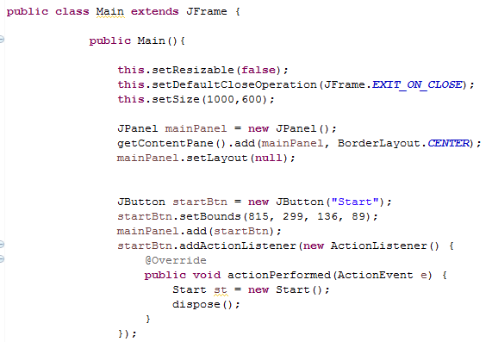

<polymorphism>

=>when we change the right pane, we made the pinterface class. we made concept class in combobox to interface the pInterface.

pInterface handles classes which is left over as objects. in this part, we use polymorphism. by method that only call panel, we can call panel about each concept.

=>also quiz question by making the new class grouped by question type, we used polymorphism by doing them we can manage the class easily.

<interfaces>

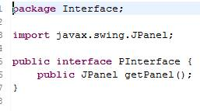

<abstract>

we will make the new class with abstract named stage.

then we make the easy normal hard class inherit from stage by doing them, it could be very useful to maintenance when we handle stage class or edit the class.

<encapsulation>

Class ‘Setting VO’, If make constuctor, we need the information before, but using encapsulation(getter, setter), more efficient to maintenance.

<Test Table>

|  |  |  |  |
| --- | --- | --- | --- |
| Test Case | Input | Expected Output | Actual Output |
| Main | Start or quit button action that user makes | Start – go to next page  Quit – close the App | Start – go to next page  Quit – close the App |
| Level | Level button(easy, normal, hard)’s action that user makes. | Easy – go to easy’ concept page  Normal – pop up the password page  Hard – pop up the password page | Easy – go to easy’ concept page  Normal – pop up the password page  Hard – pop up the password page |
| Concept | Concept in combobox that user selects | Left panel – text that are explain about selected concept  Right panel – visual contents which is related to selected concept | Left panel – text that are explain selected concept  Right panel – visual contents which is related to selected concept |
| Objective Quiz | One of the radio button action which user selected | Right answer - new pop up page says “right” and go to next quiz  Wrong answer – new pop up page says “wrong” and the reason that choice is wrong | Right answer - new pop up page says “right” and go to next quiz  Wrong answer – new pop up page says “wrong” and the reason that choice is wrong |
| Order sequence Quiz | Integer in the text area | Right – new pop up page says right and go to next quiz  Wrong – new pop up page says wrong | Right – new pop up page says right and go to next quiz  Wrong – new pop up page says wrong |
| Writing Quiz | String in the text area which user typed | Right – new pop up page says right and go to level select page  Wrong – new pop up page says wrong | Right – new pop up page says right and go to level select page  Wrong – new pop up page says wrong |
| Password Input | Password which user got before level. | Right – go to concept page include selected level  Wrong – new pop up page says wrong password | Right – go to concept page include selected level  Wrong – new pop up page says wrong password |

< Declaration of used libraries and borrowed code>

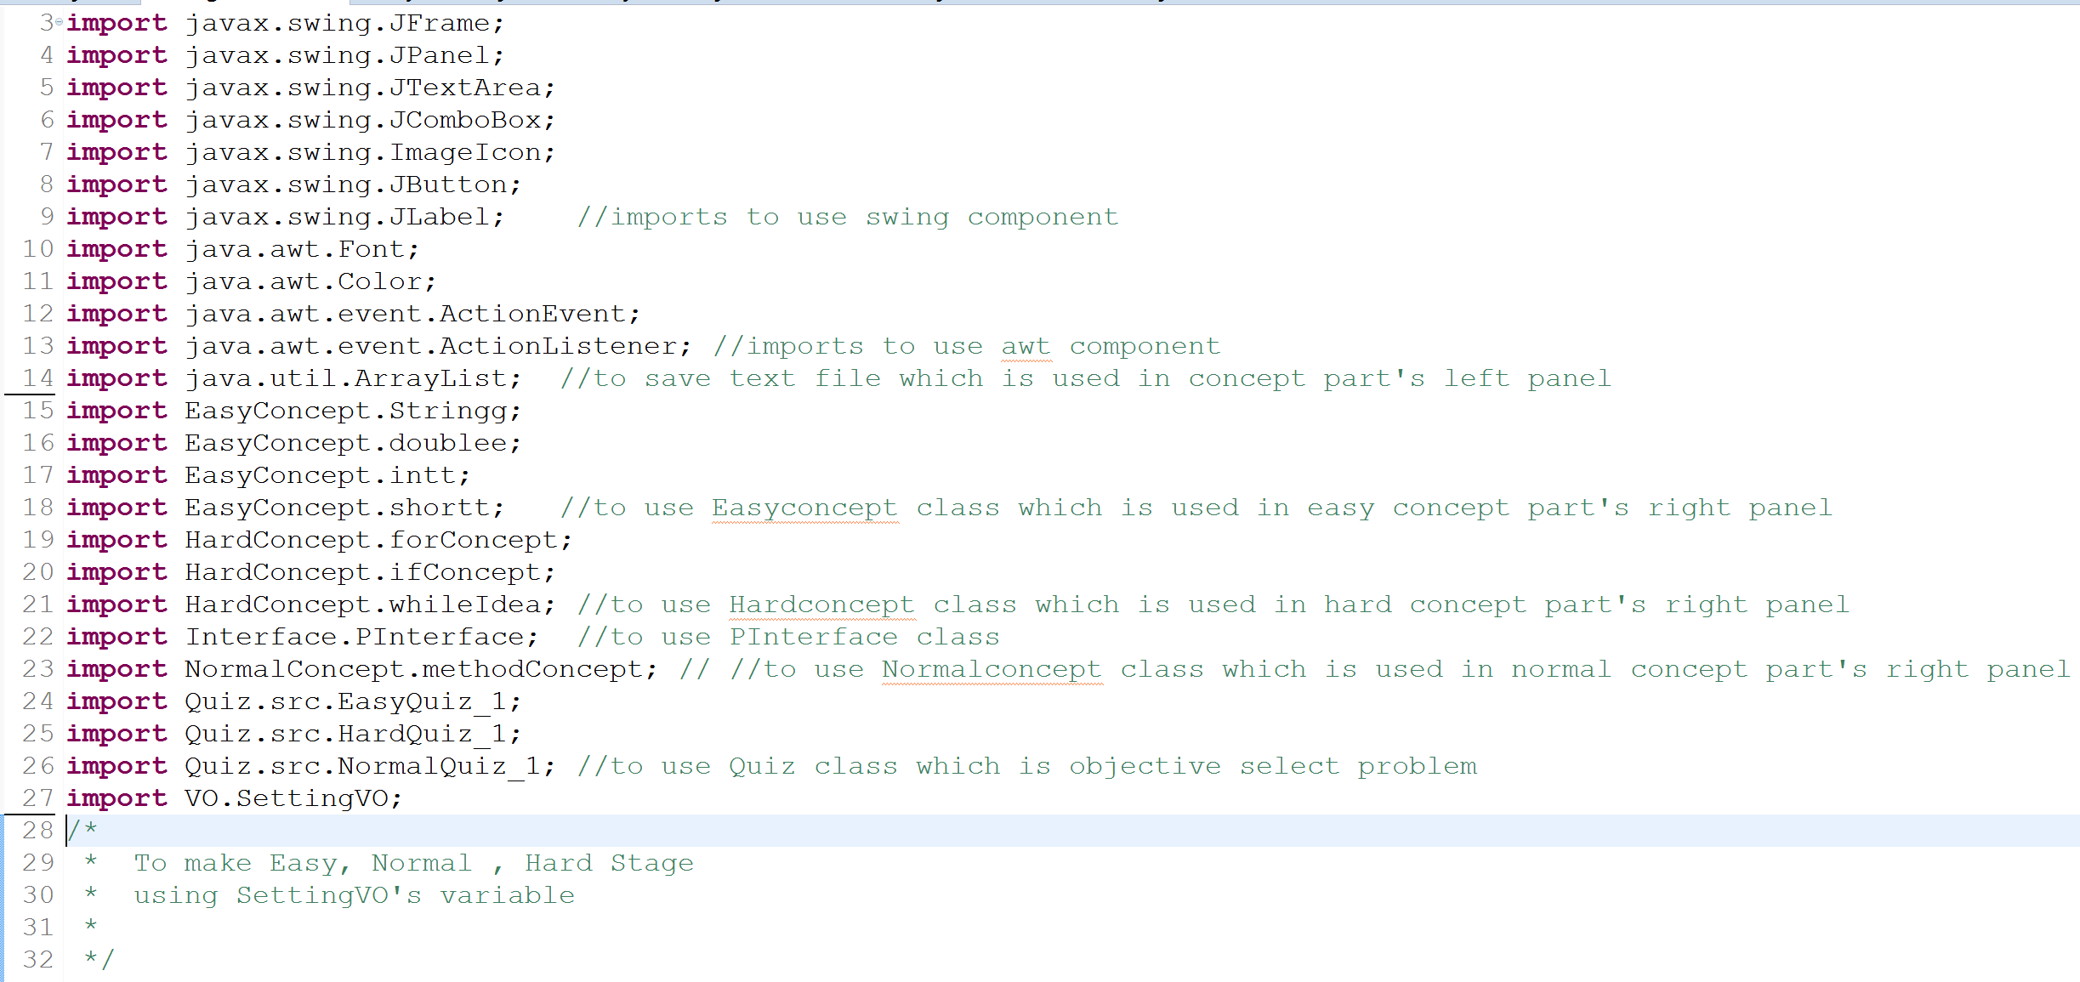

<Team member roles>

Park sung hyun : Development, supervise project, Combine Whole classes, technical Suggestion.

Jin won jun : Development, Making Concept Ideas, Making Quiz, Concept Suggestions

Son jea man : Development, Making Concept Ideas, Making Quiz, Concept Suggestions

Rho geun tak : Development, Making Concept Ideas, Making Quiz, Concept Suggestions

<Source Code review>

(Main)

package GUI;

import java.awt.event.ActionEvent;

import java.awt.event.ActionListener;

import javax.swing.JFrame;

import javax.swing.JPanel;

import java.awt.BorderLayout;

import javax.swing.ImageIcon;

import javax.swing.JButton;

import javax.swing.JLabel;

/**

* this class main Frame

* user choice 'Start' or 'Exit'

*

* @author PPPSH

*

*/

public class Main extends JFrame {

public Main(){

this.setResizable(false);

this.setDefaultCloseOperation(JFrame.EXIT_ON_CLOSE);

this.setSize(1000,600);

JPanel mainPanel = new JPanel();

getContentPane().add(mainPanel, BorderLayout.CENTER);

mainPanel.setLayout(null);

JButton startBtn = new JButton("Start");

startBtn.setBounds(815, 299, 136, 89);

mainPanel.add(startBtn);

startBtn.addActionListener(new ActionListener() {

@Override

public void actionPerformed(ActionEvent e) {

new Start();

dispose();

}

});

JButton exitBtn = new JButton("Exit");

exitBtn.setBounds(815, 429, 136, 89);

mainPanel.add(exitBtn);

exitBtn.addActionListener(new ActionListener() {

@Override

public void actionPerformed(ActionEvent e) {

dispose();

}

});

JLabel mainLabel = new JLabel("");

mainLabel.setIcon(new ImageIcon("src/res/teemu.jpg"));

mainLabel.setBounds(25, 6, 667, 538);

mainPanel.add(mainLabel);

this.setVisible(true);

}

public static void main(String[] args) {

new Main();

}

}

---------------------------------------------------------------------------------------------------------------------------

(start)

package GUI;

import javax.swing.JButton;

import javax.swing.JFrame;

import javax.swing.JPanel;

import java.awt.event.ActionListener;

import java.awt.event.ActionEvent;

import java.awt.Font;

import javax.swing.JLabel;

import javax.swing.JOptionPane;

import javax.swing.JTextField;

import Password.Password;

import VO.SettingVO;

/**

* Choice Start, Normal, Hard

* @author PPPSH

*

*/

public class Start extends JFrame {

JButton easyBtn;

JButton normalBtn;

JButton hardBtn;

JFrame passPop;

int normalPass;

int hardPass;

public Start() {

Password pass = Password.getPass(); //Singleton pattern

normalPass = pass.getNormal();

hardPass = pass.getHard();

this.setResizable(false);

this.setDefaultCloseOperation(JFrame.EXIT_ON_CLOSE);

this.setSize(1000, 600);

getContentPane().setLayout(null);

JPanel startPanel = new JPanel();

startPanel.setBounds(34, 10, 1000, 578);

getContentPane().add(startPanel);

startPanel.setLayout(null);

System.out.println(normalPass);

System.out.println(hardPass);

//Easy stage Setting

JButton easyButton = new JButton("EASY");

easyButton.setFont(new Font("Elephant", Font.ITALIC, 32));

easyButton.setBounds(46, 130, 233, 266);

startPanel.add(easyButton);

easyButton.addActionListener(new ActionListener() {

@Override

public void actionPerformed(ActionEvent e) {

String stage = "Easy";

String p = "We Start about Variable";

String step = "Easy Step!";

String[] list = { "Choice!", "String", "short", "int", "double" };

new StageFrame(new SettingVO(stage, p, step, list));

dispose();

}

});

//Normal stage Setting

JButton normalBtn = new JButton("Normal");

normalBtn.setFont(new Font("Elephant", Font.PLAIN, 32));

normalBtn.setBounds(349, 126, 233, 274);

startPanel.add(normalBtn);

normalBtn.addActionListener(new ActionListener() {

public void actionPerformed(ActionEvent e) {

passPop = new JFrame();

JTextField inputPass;

JButton conPass;

passPop.setVisible(true);

passPop.setSize(200, 200);

JPanel passPanel = new JPanel();

passPop.setContentPane(passPanel);

passPanel.add(new JLabel("INPUT PASSWORD !"));

passPanel.add(inputPass = new JTextField(15));

passPanel.add(conPass = new JButton("SUBMIT!"));

conPass.addActionListener(new ActionListener() {

@Override

public void actionPerformed(ActionEvent e) {

if (inputPass.getText().equals(String.valueOf(normalPass))) {

passPop.dispose();

String stage = "Normal";

String p = "We Start about Method";

String step = "Normal Step!";

String[] list = { "Choice!", "What a Method", "How Method", "Why Method" };

new StageFrame(new SettingVO(stage, p, step, list));

dispose();

} else {

JOptionPane.showMessageDialog(passPop, "Wrong Password, Get on before Step! ");

passPop.dispose();

}

}

});

}

});

//Hard stage Setting

hardBtn = new JButton("Hard");

hardBtn.setFont(new Font("Elephant", Font.ITALIC, 32));

hardBtn.setBounds(658, 126, 233, 274);

startPanel.add(hardBtn);

JLabel lblNewLabel = new JLabel(" LEVEL SELECT");

lblNewLabel.setFont(new Font("Arial", Font.PLAIN, 32));

lblNewLabel.setBounds(264, 23, 403, 93);

startPanel.add(lblNewLabel);

hardBtn.addActionListener(new ActionListener() {

public void actionPerformed(ActionEvent e) {

passPop = new JFrame();

JTextField inputPass;

JButton conPass;

passPop.setVisible(true);

passPop.setSize(200, 200);

JPanel passPanel = new JPanel();

passPop.setContentPane(passPanel);

passPanel.add(new JLabel("INPUT PASSWORD !"));

passPanel.add(inputPass = new JTextField(15));

passPanel.add(conPass = new JButton("SUBMIT!"));

conPass.addActionListener(new ActionListener() {

@Override

public void actionPerformed(ActionEvent e) {

if (inputPass.getText().equals(String.valueOf(hardPass))) {

passPop.dispose();

String stage = "Hard";

String p = "We Start about For , If , While ";

String step = "Normal Step!";

String[] list = { "Choice!", "For", "If", "While" };

new StageFrame(new SettingVO(stage, p, step, list));

dispose();

} else {

JOptionPane.showMessageDialog(passPop, "Wrong Password, Get on before Step! ");

passPop.dispose();

}

}

});

}

});

this.setVisible(true);

}

}

---------------------------------------------------------------------------------------------------------------------------

(password)

package Password;

/**

* Using Singleton pattern, other class don't create password,

* and don't change because don't make setter;

* @author PPPSH

*

*/

public class Password {

private static Password pass = new Password();

private int normalPass;

private int hardPass;

private Password(){

normalPass = (int)(Math.random()*10000); // random

hardPass = (int)(Math.random()*10000); //

}

public static Password getPass(){

return pass;

}

public int getNormal(){

return normalPass;

}

public int getHard(){

return hardPass;

}

}

---------------------------------------------------------------------------------------------------------------------------

(stageframe)

package GUI;

import javax.swing.JFrame;

import javax.swing.JPanel;

import javax.swing.JTextArea;

import javax.swing.JComboBox;

import javax.swing.JLabel;

import java.awt.Color;

import java.awt.event.ActionEvent;

import java.awt.event.ActionListener;

import java.util.ArrayList;

import EasyConcept.Stringg;

import EasyConcept.doublee;

import EasyConcept.intt;

import EasyConcept.shortt;

import HardConcept.forConcept;

import HardConcept.ifConcept;

import HardConcept.whileIdea;

import Interface.PInterface;

import NormalConcept.methodConcept;

import Quiz.src.EasyQuiz_1;

import Quiz.src.HardQuiz_1;

import Quiz.src.NormalQuiz_1;

import VO.SettingVO;

import javax.swing.ImageIcon;

import javax.swing.JButton;

import java.awt.Font;

/**

* This class make Easy, Normal, Hard Frame using VO class

* VO Class has String stage, panelName, StepName, comboList[]

* @author PPPSH

*

*/

public class StageFrame extends Stage{

private JTextArea concept;

private JPanel rightPanel;

private JPanel leftPanel;

private JPanel panel ;

private JComboBox comboBox ;

private JButton btnQuiz;

private SettingVO vo;

public StageFrame(SettingVO vo){

this.vo=vo;

init();

}

public void init(){

this.setResizable(false);

this.setDefaultCloseOperation(JFrame.EXIT_ON_CLOSE); //Auto end

this.setSize(1000,725);

getContentPane().setLayout(null);

panel = new JPanel();

panel.setBounds(6, 79, 994, 615);

getContentPane().add(panel);

panel.setLayout(null);

this.setVisible(true);

leftPanel = new JPanel(); /* make panel*/

leftPanel.setBackground(Color.YELLOW);

leftPanel.setBounds(29, 54, 459, 518);

panel.add(leftPanel);

leftPanel.setLayout(null);

concept = new JTextArea(); //JTextArea(Auto line enter) vs JTextField

concept.setFont(new Font("Lucida Grande", Font.PLAIN, 15));

concept.setEditable(false);

concept.setText(" Plese Click 'Choice!' and than when you finish the study, Go to Quiz");

concept.setBounds(27, 33, 397, 263);

leftPanel.add(concept);

concept.setColumns(10);

concept.setLineWrap(true);

concept.setColumns(10);

rightPanel = new JPanel();/*make panel*/

rightPanel.setBackground(Color.WHITE);

rightPanel.setBounds(538, 54, 435, 522);

panel.add(rightPanel);

rightPanel.setLayout(null);

JLabel IdeaTitle1 = new JLabel("Let's go ");

IdeaTitle1.setFont(new Font("휴먼편지체", Font.BOLD, 30));

IdeaTitle1.setBounds(28, 13, 152, 44);

rightPanel.add(IdeaTitle1);

JLabel IdeaTitle2 = new JLabel("With ME ! I'm very Kind !");

IdeaTitle2.setForeground(Color.BLUE);

IdeaTitle2.setFont(new Font("휴먼편지체", Font.BOLD, 30));

IdeaTitle2.setBounds(16, 54, 413, 48);

rightPanel.add(IdeaTitle2);

JLabel az = new JLabel("");

az.setBounds(66, 116, 291, 334);

az.setIcon(new ImageIcon("src/res/az.png"));

rightPanel.add(az);

JLabel panelName = new JLabel(vo.getPanelName());

panelName.setBounds(442, 22, 289, 16);

getContentPane().add(panelName);

JLabel stepName = new JLabel(vo.getStepName());

stepName.setBounds(382, 32, 111, 55);

getContentPane().add(stepName);

comboBox = new JComboBox(vo.getComboList());/*call comboBox list*/

comboBox.setBounds(488, 37, 281, 46);

getContentPane().add(comboBox);

btnQuiz = new JButton("Quiz");

btnQuiz.addActionListener(new ActionListener() {

public void actionPerformed(ActionEvent e) {

goQuiz();

}

});

btnQuiz.setBounds(811, 38, 117, 29);

getContentPane().add(btnQuiz);

buttonSetting();

}

//fr =FileRead

public void buttonSetting(){

comboBox.addActionListener(new ActionListener() {

@Override

public void actionPerformed(ActionEvent e) {

String checked=comboBox.getSelectedItem().toString();

String txt="";

ArrayList<String> list = new ArrayList<>();

if(checked.equals("String")){ /* comboBox list condition control*/

list =fr.getTxt("string");

for(String x : list){

txt = txt+" "+x;

}

concept.setText(txt);

fr.resetList();

rightPanel.setVisible(false);

changePanel(new Stringg());

}else if(checked.equals("int")){

list =fr.getTxt("int");

for(String x : list){

txt = txt+" "+x;

}

concept.setText(txt);

fr.resetList();

rightPanel.setVisible(false);

changePanel(new intt());

}else if(checked.equals("short")){

list =fr.getTxt("short");

for(String x : list){

txt = txt+" "+x;

}

concept.setText(txt);

fr.resetList();

rightPanel.setVisible(false);

changePanel(new shortt());

}else if(checked.equals("double")){

list =fr.getTxt("double");

for(String x : list){

txt = txt+" "+x;

}

concept.setText(txt);

fr.resetList();

rightPanel.setVisible(false);

changePanel(new doublee());

}else if(checked.equals("What a Method")){

list =fr.getTxt("what method");

for(String x : list){

txt = txt+" "+x;

}

concept.setText(txt);

fr.resetList();

rightPanel.setVisible(false);

changePanel(new methodConcept());

}else if(checked.equals("How Method")){

list =fr.getTxt("how method");

for(String x : list){

txt = txt+" "+x;

}

concept.setText(txt);

fr.resetList();

rightPanel.setVisible(false);

changePanel(new methodConcept());

}else if(checked.equals("Why Method")){

list =fr.getTxt("why method");

for(String x : list){

txt = txt+" "+x;

}

concept.setText(txt);

fr.resetList();

rightPanel.setVisible(false);

changePanel(new methodConcept());

}else if(checked.equals("For")){

list =fr.getTxt("For");

for(String x : list){

txt = txt+" "+x;

}

concept.setText(txt);

fr.resetList();

rightPanel.setVisible(false);

changePanel(new forConcept());

}else if(checked.equals("If")){

list =fr.getTxt("if else");

for(String x : list){

txt = txt+" "+x;

}

concept.setText(txt);

fr.resetList();

rightPanel.setVisible(false);

changePanel(new ifConcept());

}else if(checked.equals("While")){

list =fr.getTxt("while");

for(String x : list){

txt = txt+" "+x;

}

concept.setText(txt);

fr.resetList();

rightPanel.setVisible(false);

changePanel(new whileIdea());

}else if(checked.equals("Choice!")){

concept.setText(" Plese Click 'Choice!' and than when you finish the study, Go to Quiz");

rightPanel.setVisible(false);

changePanel(new HI());

}

}

});

}

public void goQuiz(){ /*level control method*/

if(vo.getStage().equals("Easy")){

new EasyQuiz_1();

}else if(vo.getStage().equals("Normal")){

new NormalQuiz_1();

}else if(vo.getStage().equals("Hard")){

new HardQuiz_1();

}

dispose();

}

//Applying Polymorphism

public void changePanel(PInterface pi)

{

rightPanel=pi.getPanel();

panel.add(rightPanel);

rightPanel.setVisible(true);

}

}

---------------------------------------------------------------------------------------------------------------------------

(stage)

package GUI;

import javax.swing.JFrame;

import Interface.PInterface;

/**

* this is Interface.

* To compel implements about Frame

* and children class using FileRead

*

*

* @author PPPSH

*

*/

public abstract class Stage extends JFrame {

FileRead fr = new FileRead();

public abstract void goQuiz();

public abstract void buttonSetting();

public abstract void changePanel(PInterface pi);

}

---------------------------------------------------------------------------------------------------------------------------

(settingVO)

package VO;

/**

* this VO class used to make Stage

* @author PPPSH

*

*/

public class SettingVO {

private String stage;

private String panelName;

private String StepName;

private String comboList[];

public SettingVO(String stage ,String panel,String step, String[] list){

this.stage=stage;

this.panelName=panel;

this.StepName = step;

this.comboList= list;

}

public String getStage() {

return stage;

}

public void setStage(String stage) {

this.stage = stage;

}

public String getPanelName() {

return panelName;

}

public void setPanelName(String panelName) {

this.panelName = panelName;

}

public String getStepName() {

return StepName;

}

public void setStepName(String stepName) {

StepName = stepName;

}

public String[] getComboList() {

return comboList;

}

public void setComboList(String[] comboList) {

this.comboList = comboList;

}

}

---------------------------------------------------------------------------------------------------------------------------

(FileRead)

package GUI;

import java.io.BufferedReader;

import java.io.File;

import java.io.FileNotFoundException;

import java.io.FileReader;

import java.io.IOException;

import java.util.ArrayList;

/**

* In this class , MainFrame leftPanel's component is made.

* This class read the text file and return text using ArrayList<String>

* Using bufferedReader.

*

* resetList() clear the ArrayList

*

* @author PPPSH

*

*/

public class FileRead {

private ArrayList<String> txt = new ArrayList<String>(); //written data storage

public ArrayList<String> getTxt(String x) {

FileRead fr = new FileRead();

String path="src/res/"+x+".txt";

BufferedReader br=null;

try { //About file not found exception handling

br=new BufferedReader(new FileReader(path));

String str=br.readLine();

while(str!=null){

this.txt.add(str); //add to Arraylist , to use StageFrame's leftPanel contents

str=br.readLine();

}

} catch (FileNotFoundException e) { /*file error control*/

e.printStackTrace();

} catch (IOException e) {

e.printStackTrace();

}finally{

try {

if(br!=null)

br.close();

} catch (IOException e) {

e.printStackTrace();

}

}

return this.txt;

}

public void resetList(){

this.txt.clear(); //arrayList initialize

}

}

---------------------------------------------------------------------------------------------------------------------------

(PInterface)

package Interface; /*every Concept methods return panel*/

import javax.swing.JPanel;

public interface PInterface {

public JPanel getPanel();

}

---------------------------------------------------------------------------------------------------------------------------

(HI)

package GUI;

import java.awt.Color;

import java.awt.Font;

import javax.swing.ImageIcon;

import javax.swing.JLabel;

import javax.swing.JPanel;

import Interface.PInterface;

/**

* this class about MainFrame's Right panel

* when user check comboBox 'Choice!'

* this panel is not explain, Just manual and refresh.

*

* @author PPPSH

*

*/

public class HI extends JPanel implements PInterface {

public JPanel panel= new JPanel();

public HI(){

panel.setBounds(538, 70, 435, 410); /*make panel*/

panel.setLayout(null);

JLabel IdeaTitle1 = new JLabel("Let's go ");

IdeaTitle1.setFont(new Font("휴먼편지체", Font.BOLD, 30));

IdeaTitle1.setBounds(12, 13, 152, 44);

this.panel.add(IdeaTitle1);

JLabel IdeaTitle2 = new JLabel("With ME ! I'm very Kind !");

IdeaTitle2.setForeground(Color.BLUE);

IdeaTitle2.setFont(new Font("휴먼편지체", Font.BOLD, 30));

IdeaTitle2.setBounds(22, 57, 396, 48);

this.panel.add(IdeaTitle2);

JLabel az = new JLabel("");

az.setBounds(22, 115, 396, 289);

az.setIcon(new ImageIcon("src/res/az.png")); //main pic

panel.add(az);

}

//return panel

public JPanel getPanel() {

return this.panel;

}

}

---------------------------------------------------------------------------------------------------------------------------

(methodConcept)

package NormalConcept;

import java.awt.Color;

import java.awt.Font;

import java.awt.event.MouseAdapter;

import java.awt.event.MouseEvent;

import javax.swing.JButton;

import javax.swing.JLabel;

import javax.swing.JPanel;

import Interface.PInterface;

import javax.swing.ImageIcon;

/**

* about Normal's methodConcept panel

*

* @author PPPSH

*

*/

public class methodConcept extends JPanel implements PInterface{

private JPanel panel= new JPanel();

public methodConcept() {

panel.setBounds(538, 50, 435, 410);

panel.setLayout(null);

JLabel IdeaTitle1 = new JLabel("What is");

IdeaTitle1.setFont(new Font("휴먼편지체", Font.BOLD, 25));

IdeaTitle1.setBounds(0, 0, 94, 42);

panel.add(IdeaTitle1);

JLabel IdeaTitle2 = new JLabel("method?");

IdeaTitle2.setForeground(Color.BLUE);

IdeaTitle2.setFont(new Font("휴먼편지체", Font.BOLD, 30));

IdeaTitle2.setBounds(97, 0, 151, 43);

panel.add(IdeaTitle2);

JButton btnNewButton1 = new JButton("Play!");

btnNewButton1.setBounds(10, 54, 94, 87);

panel.add(btnNewButton1);

JButton btnNewButton2 = new JButton("Play!");

btnNewButton2.setBounds(10, 54, 94, 87);

panel.add(btnNewButton2);

JLabel mill = new JLabel("");

mill.setIcon(new ImageIcon("src/res/wheat.png"));

mill.setBounds(116, 53, 94, 87);

mill.setVisible(false);

panel.add(mill);

JLabel upArrow = new JLabel("");

upArrow.setIcon(new ImageIcon("src/res/arrow.png"));

upArrow.setBounds(161, 150, 25, 33);

upArrow.setVisible(false);

panel.add(upArrow);

JLabel factory = new JLabel("");

factory.setIcon(new ImageIcon("src/res/factory.png"));

factory.setBounds(127, 165, 208, 110);

panel.add(factory);

JLabel cake = new JLabel("");

cake.setIcon(new ImageIcon("src/res/cakesize.png"));

cake.setBounds(232, 276, 107, 134);

cake.setVisible(false);

panel.add(cake);

JLabel downArrow = new JLabel("");

downArrow.setIcon(new ImageIcon("src/res/arrow.png"));

downArrow.setBounds(266, 257, 25, 33);

downArrow.setVisible(false);

panel.add(downArrow);

btnNewButton1.addMouseListener(new MouseAdapter() {

@Override

public void mouseClicked(MouseEvent e) {

if(e.getSource()==btnNewButton1)

{

upArrow.setVisible(true);

mill.setVisible(true);

btnNewButton1.setVisible(false);

btnNewButton2.setVisible(true);

}

}

});

btnNewButton2.addMouseListener(new MouseAdapter() {

@Override

public void mouseClicked(MouseEvent e) {

if(e.getSource()==btnNewButton2)

{

downArrow.setVisible(true);

cake.setVisible(true);

}

}

});

}

public JPanel getPanel(){

return this.panel;

}

}

---------------------------------------------------------------------------------------------------------------------------

(doublee)

package EasyConcept;

import java.awt.Color;

import java.awt.Font;

import javax.swing.ImageIcon;

import javax.swing.JLabel;

import javax.swing.JPanel;

import Interface.PInterface;

/**

* this class about MainFrame's Right panel

* when user check comboBox 'double'

* this panel explains about double using Graphic

* because this inherits 'PInterface' , so implements getPanel to send panel

* @author PPPSH

*

*/

public class doublee extends JPanel implements PInterface{

//component about StageFrame's rightPanel

public JPanel panel= new JPanel();

public doublee() {

panel.setBounds(538, 70, 435, 410);

panel.setLayout(null);

JLabel bike = new JLabel("");

bike.setIcon(new ImageIcon("src/res/bike.png")); //in RightPanel Pic

bike.setBounds(252, 195, 150, 158);

panel.add(bike);

JLabel IdeaTitle1 = new JLabel("What is");

IdeaTitle1.setFont(new Font("휴먼편지체", Font.BOLD, 30));

IdeaTitle1.setBounds(33, 3, 150, 35);

panel.add(IdeaTitle1);

JLabel IdeaTitle2 = new JLabel("double?");

IdeaTitle2.setForeground(Color.BLUE);

IdeaTitle2.setFont(new Font("휴먼편지체", Font.BOLD, 35));

IdeaTitle2.setBounds(168, -3, 164, 42);

panel.add(IdeaTitle2);

JLabel lblNewLabel_3 = new JLabel("\"I can ride This!\"");

lblNewLabel_3.setForeground(Color.GREEN);

lblNewLabel_3.setFont(new Font("휴먼편지체", Font.BOLD, 25));

lblNewLabel_3.setBounds(74, 100, 272, 30);

panel.add(lblNewLabel_3);

JLabel lblNewLabel_4 = new JLabel("I can ride Whatever HAHA!");

lblNewLabel_4.setFont(new Font("휴먼편지체", Font.BOLD, 20));

lblNewLabel_4.setForeground(Color.RED);

lblNewLabel_4.setBounds(63, 168, 339, 24);

panel.add(lblNewLabel_4);

JLabel rider = new JLabel("");

rider.setIcon(new ImageIcon("src/res/rider.png"));

rider.setBounds(0, 216, 230, 184);

panel.add(rider);

JLabel balloon2 = new JLabel("");

balloon2.setIcon(new ImageIcon("src/res/balloon2.png"));

balloon2.setBounds(83, 48, 283, 253);

panel.add(balloon2);

}

public JPanel getPanel(){

return this.panel;

}

}

---------------------------------------------------------------------------------------------------------------------------

(intt)

package EasyConcept;

import java.awt.Color;

import java.awt.Font;

import javax.swing.ImageIcon;

import javax.swing.JLabel;

import javax.swing.JPanel;

import Interface.PInterface;

/**

* this class about MainFrame's Right panel

* when user check comboBox 'int'

* this panel explains about 'int variable' using Graphic

* @author PPPSH

*

*/

public class intt extends JPanel implements PInterface{

public JPanel panel = new JPanel();

/**

* Create the frame.

*/

public intt() {

panel.setBounds(538, 70, 435, 410);

panel.setLayout(null);

JLabel cycle = new JLabel("");

cycle.setIcon(new ImageIcon("src/res/cycle.png")); // intt up Pic

cycle.setBounds(247, 207, 160, 105);

this.panel.add(cycle);

JLabel lblNewLabel_3 = new JLabel("\"We can ride This!\""); // inner up text

lblNewLabel_3.setForeground(Color.GREEN);

lblNewLabel_3.setFont(new Font("휴먼편지체", Font.BOLD, 25));

lblNewLabel_3.setBounds(95, 109, 272, 30);

this.panel.add(lblNewLabel_3);

JLabel lblNewLabel_4 = new JLabel("But, We can't ride Bike!"); //inner text

lblNewLabel_4.setFont(new Font("휴먼편지체", Font.BOLD, 20));

lblNewLabel_4.setForeground(Color.RED);

lblNewLabel_4.setBounds(95, 149, 259, 24);

this.panel.add(lblNewLabel_4);

JLabel IdeaTitle1 = new JLabel("What is"); //inner text

IdeaTitle1.setFont(new Font("휴먼편지체", Font.BOLD, 30));

IdeaTitle1.setBounds(56, 13, 174, 35);

this.panel.add(IdeaTitle1);

JLabel IdeaTitle2 = new JLabel("int?");

IdeaTitle2.setForeground(Color.BLUE);

IdeaTitle2.setFont(new Font("휴먼편지체", Font.BOLD, 35));

IdeaTitle2.setBounds(197, 7, 192, 42);

this.panel.add(IdeaTitle2);

JLabel youth = new JLabel("");

youth.setIcon(new ImageIcon("src/res/youth.png")); // intt down Pic

youth.setBounds(12, 246, 250, 154);

this.panel.add(youth);

JLabel balloon2 = new JLabel(""); //balloon2 pic

balloon2.setIcon(new ImageIcon("src/res/balloon2.png"));

balloon2.setBounds(71, 42, 283, 253);

this.panel.add(balloon2);

}

//return this panel

public JPanel getPanel(){

return this.panel;

}

}

---------------------------------------------------------------------------------------------------------------------------

(shortt)

package EasyConcept;

import java.awt.Color;

import java.awt.Font;

import javax.swing.JPanel;

import Interface.PInterface;

import javax.swing.JLabel;

import javax.swing.ImageIcon;

/**

* this class about MainFrame's Right panel

* when user check comboBox 'short'

* this panel explains about 'short variable' using Graphic

* @author PPPSH

*

*/

public class shortt extends JPanel implements PInterface{

public JPanel panel = new JPanel();

public shortt() {

panel.setBounds(538, 70, 435, 410);

panel.setLayout(null);

JLabel minibike = new JLabel("");

minibike.setIcon(new ImageIcon("src/res/minibike.png"));

minibike.setBounds(261, 216, 120, 142);

panel.add(minibike);

JLabel lblNewLabel_4 = new JLabel("But, We can't ride Cycle, Bike!");

lblNewLabel_4.setFont(new Font("휴먼편지체", Font.BOLD, 20));

lblNewLabel_4.setForeground(Color.RED);

lblNewLabel_4.setBounds(58, 180, 323, 24);

panel.add(lblNewLabel_4);

JLabel lblNewLabel_3 = new JLabel("\"We can ride This!\"");

lblNewLabel_3.setForeground(Color.GREEN);

lblNewLabel_3.setFont(new Font("휴먼편지체", Font.BOLD, 25));

lblNewLabel_3.setBounds(84, 122, 253, 30);

panel.add(lblNewLabel_3);

JLabel balloon2 = new JLabel("");

balloon2.setIcon(new ImageIcon("src/res/balloon2.png"));

balloon2.setBounds(85, 64, 283, 253);

panel.add(balloon2);

JLabel child = new JLabel("");

child.setIcon(new ImageIcon("src/res/child.png"));

child.setBounds(0, 272, 200, 128);

panel.add(child);

JLabel IdeaTitle1 = new JLabel("What is");

IdeaTitle1.setFont(new Font("휴먼편지체", Font.BOLD, 30));

IdeaTitle1.setBounds(40, 3, 144, 35);

panel.add(IdeaTitle1);

JLabel IdeaTitle2 = new JLabel("short?");

IdeaTitle2.setForeground(Color.BLUE);

IdeaTitle2.setFont(new Font("휴먼편지체", Font.BOLD, 35));

IdeaTitle2.setBounds(180, -3, 138, 42);

panel.add(IdeaTitle2);

}

public JPanel getPanel(){

return this.panel;

}

}

---------------------------------------------------------------------------------------------------------------------------

(Stringg)

package EasyConcept;

import java.awt.Color;

import java.awt.Font;

import javax.swing.ImageIcon;

import javax.swing.JLabel;

import javax.swing.JPanel;

import Interface.PInterface;

/**

* this class about MainFrame's Right panel when user check comboBox 'String'

* this panel explains about 'short variable' using Graphic

* @author PPPSH

*

*/

public class Stringg extends JPanel implements PInterface {

public JPanel panel = new JPanel();

public Stringg() {

panel.setBounds(538, 70, 435, 410);

panel.setLayout(null);

JLabel lblNewLabel = new JLabel("");

lblNewLabel.setIcon(new ImageIcon("src/res/book.png"));

lblNewLabel.setBounds(69, 129, 300, 271);

this.panel.add(lblNewLabel);

JLabel IdeaTitle1 = new JLabel("What is");

IdeaTitle1.setFont(new Font("휴먼편지체", Font.BOLD, 30));

IdeaTitle1.setBounds(12, 13, 125, 30);

this.panel.add(IdeaTitle1);

JLabel IdeaTitle2 = new JLabel("String?");

IdeaTitle2.setForeground(Color.BLUE);

IdeaTitle2.setFont(new Font("휴먼편지체", Font.BOLD, 35));

IdeaTitle2.setBounds(139, 10, 132, 35);

this.panel.add(IdeaTitle2);

}

@Override

public JPanel getPanel() {

return this.panel;

}

}

---------------------------------------------------------------------------------------------------------------------------

(forConcept)

package HardConcept;

import javax.swing.JPanel;

import Interface.PInterface;

import javax.swing.JLabel;

import java.awt.Font;

import java.awt.Color;

import javax.swing.ImageIcon;

import javax.swing.JButton;

import java.awt.event.MouseAdapter;

import java.awt.event.MouseEvent;

/**

* about 'for' panel

* @author PPPSH

*

*/

public class forConcept extends JPanel implements PInterface{

private JLabel forIdea1;

private JLabel forIdea2;

private JLabel forIdea3;

private JLabel forIdea4;

private JLabel forIdea5;

private JButton repeat;

private JPanel panel = new JPanel();

public String conceptTexts[] = {"long", "double", "int", "short", "test2"};

public forConcept() {

panel.setBounds(538, 50, 435, 497);

panel.setLayout(null);

JLabel mario2 = new JLabel("");

mario2.setIcon(new ImageIcon("src/res/mario.png"));

mario2.setBounds(49, 204, 80, 97);

mario2.setVisible(false);

panel.add(mario2);

JLabel IdeaTitle1 = new JLabel("What is");

IdeaTitle1.setFont(new Font("휴먼편지체", Font.BOLD, 25));

IdeaTitle1.setBounds(0, 0, 94, 42);

panel.add(IdeaTitle1);

JLabel IdeaTitle2 = new JLabel("for?");

IdeaTitle2.setForeground(Color.BLUE);

IdeaTitle2.setFont(new Font("휴먼편지체", Font.BOLD, 30));

IdeaTitle2.setBounds(97, 0, 72, 43);

panel.add(IdeaTitle2);

JLabel lblNewLabel = new JLabel("(Total Step) (Up Step)");

lblNewLabel.setFont(new Font("휴먼편지체", Font.BOLD, 16));

lblNewLabel.setBounds(149, 437, 183, 33);

panel.add(lblNewLabel);

JLabel lblNewLabel_1 = new JLabel("(First Step)");

lblNewLabel_1.setFont(new Font("휴먼편지체", Font.BOLD, 16));

lblNewLabel_1.setBounds(49, 441, 94, 25);

panel.add(lblNewLabel_1);

JLabel lblNewLabel_2 = new JLabel("(Second Step)");

lblNewLabel_2.setFont(new Font("휴먼편지체", Font.BOLD, 16));

lblNewLabel_2.setBounds(30, 441, 120, 25);

lblNewLabel_2.setVisible(false);

panel.add(lblNewLabel_2);

JLabel lblNewLabel_3 = new JLabel("(Third Step)");

lblNewLabel_3.setFont(new Font("휴먼편지체", Font.BOLD, 16));

lblNewLabel_3.setBounds(49, 441,120, 25);

lblNewLabel_3.setVisible(false);

panel.add(lblNewLabel_3);

JLabel lblNewLabel_4 = new JLabel("(Forth Step)");

lblNewLabel_4.setFont(new Font("휴먼편지체", Font.BOLD, 16));

lblNewLabel_4.setBounds(49, 441, 120, 25);

lblNewLabel_4.setVisible(false);

panel.add(lblNewLabel_4);

JLabel lblNewLabel_5 = new JLabel("(Fifth Step)");

lblNewLabel_5.setFont(new Font("휴먼편지체", Font.BOLD, 16));

lblNewLabel_5.setBounds(49, 441, 120, 25);

lblNewLabel_5.setVisible(false);

panel.add(lblNewLabel_5);

JLabel totalStep = new JLabel("\u2191");

totalStep.setForeground(Color.BLUE);

totalStep.setFont(new Font("휴먼편지체", Font.BOLD, 20));

totalStep.setBounds(181, 423, 16, 33);

panel.add(totalStep);

JLabel firstStep = new JLabel("\u2191");

firstStep.setForeground(Color.BLUE);

firstStep.setFont(new Font("휴먼편지체", Font.BOLD, 20));

firstStep.setBounds(112, 423, 16, 33);

panel.add(firstStep);

JLabel upStep = new JLabel("\u2191");

upStep.setForeground(Color.BLUE);

upStep.setFont(new Font("휴먼편지체", Font.BOLD, 20));

upStep.setBounds(253, 423, 16, 33);

panel.add(upStep);

JLabel step = new JLabel("");

step.setIcon(new ImageIcon("src/res/stair.png"));

step.setBounds(95, 88, 273, 290);

panel.add(step);

JLabel mario3 = new JLabel("");

mario3.setIcon(new ImageIcon("src/res/mario.png"));

mario3.setBounds(123, 136, 80, 97);

mario3.setVisible(false);

panel.add(mario3);

JLabel mario1 = new JLabel("");

mario1.setIcon(new ImageIcon("src/res/mario.png"));

mario1.setBounds(-18, 281, 80, 97);

panel.add(mario1);

JLabel mario4 = new JLabel("");

mario4.setIcon(new ImageIcon("src/res/mario.png"));

mario4.setBounds(192, 64, 80, 97);

mario4.setVisible(false);

panel.add(mario4);

JLabel mario5 = new JLabel("");

mario5.setIcon(new ImageIcon("src/res/mario.png"));

mario5.setBounds(253, 0, 80, 97);

mario5.setVisible(false);

panel.add(mario5);

JLabel forIdea = new JLabel("for( i=0 ; i<5 ; i++)");

forIdea.setFont(new Font("휴먼편지체", Font.BOLD, 25));

forIdea.setBounds(31, 367, 290, 79);

panel.add(forIdea);

JButton btnNewButton1 = new JButton("Play!");

btnNewButton1.setBounds(10, 54, 94, 87);

panel.add(btnNewButton1);

JButton btnNewButton2 = new JButton("Play!");

btnNewButton2.setBounds(10, 54, 94, 87);

btnNewButton2.setVisible(false);

panel.add(btnNewButton2);

JButton btnNewButton3 = new JButton("Play!");

btnNewButton3.setBounds(10, 54, 94, 87);

btnNewButton3.setVisible(false);

panel.add(btnNewButton3);

JButton btnNewButton4 = new JButton("Play!");

btnNewButton4.setBounds(10, 54, 94, 87);

btnNewButton4.setVisible(false);

panel.add(btnNewButton4);

btnNewButton1.addMouseListener(new MouseAdapter() {

@Override

public void mouseClicked(MouseEvent e) {

if(e.getSource()==btnNewButton1)

{

mario1.setVisible(false);

forIdea.setVisible(false);

mario2.setVisible(true);

lblNewLabel_1.setVisible(false);

lblNewLabel_2.setVisible(true);

forIdea2 = new JLabel("for( i=1 ; i<5 ; i++)");

forIdea2.setFont(new Font("휴먼편지체", Font.BOLD, 25));

forIdea2.setBounds(31, 367, 290, 79);

panel.add(forIdea2);

btnNewButton1.setVisible(false);

btnNewButton2.setVisible(true);

}

}

});

btnNewButton2.addMouseListener(new MouseAdapter() {

@Override

public void mouseClicked(MouseEvent e) {

if(e.getSource()==btnNewButton2)

{

mario2.setVisible(false);

forIdea2.setVisible(false);

mario3.setVisible(true);

lblNewLabel_2.setVisible(false);

lblNewLabel_3.setVisible(true);

forIdea3 = new JLabel("for( i=2 ; i<5 ; i++)");

forIdea3.setFont(new Font("휴먼편지체", Font.BOLD, 25));

forIdea3.setBounds(31, 367, 290, 79);

panel.add(forIdea3);

btnNewButton2.setVisible(false);

btnNewButton3.setVisible(true);

}

}

});

btnNewButton3.addMouseListener(new MouseAdapter() {

@Override

public void mouseClicked(MouseEvent e) {

if(e.getSource()==btnNewButton3)

{

mario3.setVisible(false);

forIdea3.setVisible(false);

mario4.setVisible(true);

lblNewLabel_3.setVisible(false);

lblNewLabel_4.setVisible(true);

forIdea4 = new JLabel("for( i=3 ; i<5 ; i++)");

forIdea4.setFont(new Font("휴먼편지체", Font.BOLD, 25));

forIdea4.setBounds(31, 367, 290, 79);

panel.add(forIdea4);

btnNewButton3.setVisible(false);

btnNewButton4.setVisible(true);

}

}

});

btnNewButton4.addMouseListener(new MouseAdapter() {

@Override

public void mouseClicked(MouseEvent e) {

if(e.getSource()==btnNewButton4)

{

mario4.setVisible(false);

forIdea4.setVisible(false);

mario5.setVisible(true);

lblNewLabel_4.setVisible(false);

lblNewLabel_5.setVisible(true);

forIdea5 = new JLabel("for( i=4 ; i<5 ; i++)");

forIdea5.setFont(new Font("휴먼편지체", Font.BOLD, 25));

forIdea5.setBounds(31, 367, 290, 79);

panel.add(forIdea5);

btnNewButton4.setVisible(false);

}

}

});

}

public JPanel getPanel(){

return this.panel;

}

}

---------------------------------------------------------------------------------------------------------------------------

(ifConcept)

package HardConcept; /*‘ifConcept’ class Hard level comboBox index ’if’ on right panel*/

import java.awt.Color;

import java.awt.Font;

import javax.swing.JLabel;

import javax.swing.JPanel;

import Interface.PInterface;

import javax.swing.ImageIcon;

public class ifConcept extends JPanel implements PInterface{

private JPanel panel = new JPanel();

public ifConcept() {

panel.setBounds(538, 50, 435, 410);

panel.setLayout(null);

JLabel lblNewLabel = new JLabel("...if???");

lblNewLabel.setForeground(Color.BLUE);

lblNewLabel.setFont(new Font("휴먼편지체", Font.BOLD, 30));

lblNewLabel.setBounds(231, 53, 81, 60);

panel.add(lblNewLabel);

JLabel IdeaTitle1 = new JLabel("What is");

IdeaTitle1.setFont(new Font("휴먼편지체", Font.BOLD, 25));

IdeaTitle1.setBounds(0, 0, 94, 42);

panel.add(IdeaTitle1);

JLabel IdeaTitle2 = new JLabel("if?");

IdeaTitle2.setForeground(Color.BLUE);

IdeaTitle2.setFont(new Font("휴먼편지체", Font.BOLD, 30));

IdeaTitle2.setBounds(97, 0, 57, 43);

panel.add(IdeaTitle2);

JLabel lblNewThink = new JLabel("");

lblNewThink.setIcon(new ImageIcon("src/res/think.png"));

lblNewThink.setBounds(0, 152, 200, 248);

panel.add(lblNewThink);

JLabel lblNewBalloon = new JLabel("");

lblNewBalloon.setIcon(new ImageIcon("src/res/balloon.png"));

lblNewBalloon.setBounds(202, 10, 156, 180);

panel.add(lblNewBalloon);

}

public JPanel getPanel(){

return this.panel;

}

}

---------------------------------------------------------------------------------------------------------------------------

(whileIdea)

package HardConcept; /*’whileIdea’ class Hard level comboBox index ‘while’ on right panel*/

import java.awt.BorderLayout;

import java.awt.Color;

import java.awt.EventQueue;

import java.awt.Font;

import javax.swing.JFrame;

import javax.swing.JLabel;

import javax.swing.JPanel;

import javax.swing.border.EmptyBorder;

import Interface.PInterface;

import javax.swing.ImageIcon;

public class whileIdea extends JFrame implements PInterface{

private JPanel panel = new JPanel();

public whileIdea() {

panel.setBounds(538, 50, 435, 410);

panel.setLayout(null);

JLabel lblNewLabel_1 = new JLabel("Run until Turn off button!");

lblNewLabel_1.setForeground(Color.MAGENTA);

lblNewLabel_1.setFont(new Font("휴먼편지체", Font.BOLD, 20));

lblNewLabel_1.setBounds(118, 72, 278, 50);

panel.add(lblNewLabel_1);

JLabel IdeaTitle1 = new JLabel("What is");

IdeaTitle1.setFont(new Font("휴먼편지체", Font.BOLD, 25));

IdeaTitle1.setBounds(0, 0, 94, 42);

panel.add(IdeaTitle1);

JLabel IdeaTitle2 = new JLabel("While?");

IdeaTitle2.setForeground(Color.BLUE);

IdeaTitle2.setFont(new Font("휴먼편지체", Font.BOLD, 30));

IdeaTitle2.setBounds(97, 0, 115, 43);

panel.add(IdeaTitle2);

JLabel run = new JLabel("");

run.setIcon(new ImageIcon("src/res/run.png"));

run.setBounds(0, 201, 250, 209);

panel.add(run);

JLabel lblNewLabel = new JLabel("");

lblNewLabel.setIcon(new ImageIcon("src/res/balloon1.png"));

lblNewLabel.setBounds(95, 0, 340, 304);

panel.add(lblNewLabel);

}

public JPanel getPanel(){

return this.panel;

}

}

---------------------------------------------------------------------------------------------------------------------------

(EasyQuiz_1)

package Quiz.src;

import java.awt.Container;

import java.awt.Font;

import java.awt.event.ActionEvent;

import java.awt.event.ActionListener;

import java.awt.event.ItemEvent;

import java.awt.event.ItemListener;

import javax.swing.BoxLayout;

import javax.swing.JButton;

import javax.swing.JFrame;

import javax.swing.JLabel;

import javax.swing.JOptionPane;

import javax.swing.JRadioButton;

import javax.swing.ButtonGroup;

public class EasyQuiz_1 extends JFrame implements ActionListener,ItemListener{

int answer=1; //1,2,3,4 중 원하는 값 답으로 설정

int choosed;

JFrame frame;

JRadioButton check1;

JRadioButton check2;

JRadioButton check3;

JRadioButton check4;

JLabel label;

private final ButtonGroup buttonGroup = new ButtonGroup();

public EasyQuiz_1(){

frame = new JFrame();

JButton button = new JButton("Submit");

button.addActionListener(this);

check1 = new JRadioButton("int x=1;");

buttonGroup.add(check1);

check2 = new JRadioButton("long y=10.44");

buttonGroup.add(check2);

check3 = new JRadioButton("double x=123123123123123123123");

buttonGroup.add(check3);

check4 = new JRadioButton("short w= 99999999;");

buttonGroup.add(check4);

label = new JLabel();

check1.addItemListener(this);

check2.addItemListener(this);

check3.addItemListener(this);

check4.addItemListener(this);

Container pane = frame.getContentPane();

pane.setLayout(new BoxLayout(pane,BoxLayout.Y_AXIS));

JLabel q=new JLabel("Question1");

q.setFont(new Font("휴먼편지체", Font.PLAIN, 20));

pane.add(q);

JLabel p=new JLabel("Choosing right code.");

p.setFont(new Font("휴먼편지체", Font.PLAIN, 16));

pane.add(p);

pane.add(check1);

pane.add(check2);

pane.add(check3);

pane.add(check4);

pane.add(button);

pane.add(label);

frame.setSize(500, 500);

frame.setVisible(true);

}

@Override

public void actionPerformed(ActionEvent e) {

if(choosed==answer){

JOptionPane.showMessageDialog(null,"Correct!");

frame.setVisible(false);

EasyQuiz_2 q=new EasyQuiz_2();

q.main(null);

}

else if(choosed==2){

JOptionPane.showMessageDialog(null,"Wrong answer!\n"+"long can't use the real number.\n"+"Try again");

}

else if(choosed==3){

JOptionPane.showMessageDialog(null,"Wrong answer!\n"+"Maximum number that long can use is 9223372036854775807.\n"+"Try again");

}

else if(choosed==4){

JOptionPane.showMessageDialog(null,"Wrong answer!\n"+"Maximum number that short can use is 32767\n"+"Try again");

}

}

@Override

public void itemStateChanged(ItemEvent e) {

// TODO Auto-generated method stub

if (check1.isSelected()){

choosed=1;

}

if (check2.isSelected()){

choosed=2;

}

if(check3.isSelected()){

choosed=3;

}

if(check4.isSelected()){

choosed=4;

}

}

}

---------------------------------------------------------------------------------------------------------------------------

(EasyQuiz_2)

package Quiz.src;

import java.awt.BorderLayout;

import java.awt.EventQueue;

import javax.swing.JFrame;

import javax.swing.JPanel;

import javax.swing.border.EmptyBorder;

import javax.swing.JLabel;

import javax.swing.JOptionPane;

import javax.swing.ImageIcon;

import java.awt.Font;

import javax.swing.JTextField;

import javax.swing.JButton;

import java.awt.event.MouseAdapter;

import java.awt.event.MouseEvent;

public class EasyQuiz_2 extends JFrame {

private JPanel contentPane;

private JTextField box2;

private JTextField box1;

private JTextField box3;

private JTextField box4;

/**

* Launch the application.

*/

public static void main(String[] args) {

EventQueue.invokeLater(new Runnable() {

public void run() {

try {

EasyQuiz_2 frame = new EasyQuiz_2();

frame.setVisible(true);

} catch (Exception e) {

e.printStackTrace();

}

}

});

}

/**

* Create the frame.

*/

public EasyQuiz_2() {

setDefaultCloseOperation(JFrame.EXIT_ON_CLOSE);

setBounds(100, 100, 480, 495);

contentPane = new JPanel();

contentPane.setBorder(new EmptyBorder(5, 5, 5, 5));

contentPane.setLayout(new BorderLayout(0, 0));

setContentPane(contentPane);

JPanel panel = new JPanel();

contentPane.add(panel, BorderLayout.CENTER);

panel.setLayout(null);

JLabel lblNewLabel_5 = new JLabel("(4) Long ");

lblNewLabel_5.setBounds(104, 254, 116, 15);

panel.add(lblNewLabel_5);

JLabel lblNewLabel_4 = new JLabel("(3) Int ");

lblNewLabel_4.setBounds(104, 229, 57, 15);

panel.add(lblNewLabel_4);

JLabel lblNewLabel_3 = new JLabel("(2) Byte ");

lblNewLabel_3.setBounds(104, 204, 57, 15);

panel.add(lblNewLabel_3);

JLabel lblNewLabel_2 = new JLabel("(1) Short ");

lblNewLabel_2.setBounds(104, 179, 67, 15);

panel.add(lblNewLabel_2);

JLabel q2 = new JLabel("Question2");

q2.setFont(new Font("휴먼편지체", Font.PLAIN, 20));

q2.setBounds(0, 0, 122, 44);

panel.add(q2);

JLabel hellopic = new JLabel("");

hellopic.setIcon(new ImageIcon(""));

hellopic.setBounds(61, 76, 217, 301);

panel.add(hellopic);

JLabel q2problem = new JLabel("Arrange them in the order of range from small to big.");

q2problem.setFont(new Font("휴먼편지체", Font.PLAIN, 16));

q2problem.setBounds(0, 90, 380, 60);

panel.add(q2problem);

box1 = new JTextField();

box1.setColumns(10);

box1.setBounds(0, 387, 47, 49);

panel.add(box1);

box2 = new JTextField();

box2.setBounds(61, 387, 47, 49);

panel.add(box2);

box2.setColumns(10);

box3 = new JTextField();

box3.setColumns(10);

box3.setBounds(120, 387, 47, 49);

panel.add(box3);

box4 = new JTextField();

box4.setColumns(10);

box4.setBounds(179, 387, 47, 49);

panel.add(box4);

JLabel arrow1 = new JLabel("\u2192");

arrow1.setBounds(47, 404, 18, 15);

panel.add(arrow1);

JLabel arrow2 = new JLabel("\u2192");

arrow2.setBounds(104, 403, 18, 16);

panel.add(arrow2);

JLabel arrow3 = new JLabel("\u2192");

arrow3.setBounds(166, 399, 18, 24);

panel.add(arrow3);

JButton btnNewButton_1 = new JButton("Check");

btnNewButton_1.addMouseListener(new MouseAdapter() {

@Override

public void mouseClicked(MouseEvent e)

{

System.out.println(box1.getText());

System.out.println(box2.getText());

System.out.println(box3.getText());

System.out.println(box4.getText());

//order correct

if((box1.getText().equals("2"))&&(box2.getText().equals("1"))&&(box3.getText().equals("3"))&&(box4.getText().equals("4")))

{

System.out.println("correct");

JOptionPane.showMessageDialog(null,"Correct!");

dispose();

EasyQuiz_3 q=new EasyQuiz_3();

}

else

{

JOptionPane.showMessageDialog(null,"Wrong!");

}

}

});

btnNewButton_1.setBounds(254, 387, 79, 49);

panel.add(btnNewButton_1);

}

}

---------------------------------------------------------------------------------------------------------------------------

(EasyQuiz_3)

package Quiz.src;

import java.awt.Font;

import java.awt.event.ActionEvent;

import java.awt.event.ActionListener;

import javax.swing.BoxLayout;

import javax.swing.JButton;

import javax.swing.JFrame;

import javax.swing.JLabel;

import javax.swing.JOptionPane;

import javax.swing.JPanel;

import javax.swing.JTextField;

import GUI.Start;

import Password.Password;

public class EasyQuiz_3 extends JFrame {

JPanel jp = new JPanel();

JButton button;

JLabel l1;

JLabel l2;

JLabel l3;

JButton b1;

JButton b2;

JButton b3;

JTextField t1;

JTextField t2;

JTextField t3;

int normalPass;

public EasyQuiz_3() {

Password pass = Password.getPass();

normalPass = pass.getNormal();

this.setResizable(false);

this.setDefaultCloseOperation(JFrame.EXIT_ON_CLOSE);

this.setBounds(0, 0, 500, 473);

jp.setLayout(new BoxLayout(jp, BoxLayout.Y_AXIS));

this.setContentPane(jp);

// random show problem you will add, or using file I/O more sentence

// able to add

int i = ((int) (Math.random() * 10) / 4);

String[] text = { ("int x=3;"), ("double y=3.14;"), ("long z=123;"), ("short s=1;") };

JLabel p = new JLabel("Write codes correctly.");

p.setFont(new Font("휴먼편지체", Font.PLAIN, 16));

jp.add(p);

jp.add(l1 = new JLabel(text[i]));

JTextField t1 = new JTextField(20);

t1.setBounds(50, 100, 20, 20);

jp.add(t1);

jp.add(button = new JButton("Submit"));

button.addActionListener(new ActionListener() {

@Override

public void actionPerformed(ActionEvent e) {

if (t1.getText().equals(l1.getText())) {

JOptionPane.showMessageDialog(jp, "Correct! next Stage's PASSWORD" + " " + normalPass);

new Start();

dispose();

} else {

JOptionPane.showMessageDialog(jp, "Wrong!");

}

}

});

this.setVisible(true);

}

}

---------------------------------------------------------------------------------------------------------------------------

(NormalQuiz_1)

package Quiz.src;

import java.awt.Container;

import java.awt.Font;

import java.awt.GridLayout;

import java.awt.event.ActionEvent;

import java.awt.event.ActionListener;

import java.awt.event.ItemEvent;

import java.awt.event.ItemListener;

import javax.swing.BoxLayout;

import javax.swing.JButton;

import javax.swing.JCheckBox;

import javax.swing.JFrame;

import javax.swing.JLabel;

import javax.swing.JOptionPane;

import javax.swing.JRadioButton;

import javax.swing.ButtonGroup;

public class NormalQuiz_1 extends JFrame implements ActionListener,ItemListener{

int answer=3; //1,2,3,4 setting answer

int choosed;

JFrame frame;

JRadioButton check1;

JRadioButton check2;

JRadioButton check3;

JRadioButton check4;

JLabel label;

private final ButtonGroup buttonGroup = new ButtonGroup();

public NormalQuiz_1(){

frame = new JFrame();

JButton button = new JButton("Submit");

button.addActionListener(this);

check1 = new JRadioButton("return pra;");

buttonGroup.add(check1);

check2 = new JRadioButton("return false;");

buttonGroup.add(check2);

check3 = new JRadioButton("return 3.14;");

buttonGroup.add(check3);

check4 = new JRadioButton("return 'j';");

buttonGroup.add(check4);

label = new JLabel();

check1.addItemListener(this);

check2.addItemListener(this);

check3.addItemListener(this);

check4.addItemListener(this);

Container pane = frame.getContentPane();

pane.setLayout(new BoxLayout(pane,BoxLayout.Y_AXIS));

JLabel q=new JLabel("Question1");

q.setFont(new Font("휴먼편지체", Font.PLAIN, 20));

pane.add(q);

JLabel p=new JLabel("There is a method.");

p.setFont(new Font("휴먼편지체", Font.PLAIN, 16));

pane.add(p);

pane.add(new JLabel("double aaa(int pra){"));

pane.add(new JLabel("'here'"));

pane.add(new JLabel("}"));

JLabel p3=new JLabel("In 'here',there will be return code.");

p3.setFont(new Font("휴먼편지체", Font.PLAIN, 16));

pane.add(p3);

JLabel p4=new JLabel("what is a right return code?");

p4.setFont(new Font("휴먼편지체", Font.PLAIN, 16));

pane.add(p4);

pane.add(check1);

pane.add(check2);

pane.add(check3);

pane.add(check4);

pane.add(button);

pane.add(label);

frame.setSize(500, 500);

frame.setVisible(true);

}

@Override

public void actionPerformed(ActionEvent e) {

// TODO Auto-generated method stub

if(choosed==answer){

JOptionPane.showMessageDialog(null,"Correct!");

//다음 문제로 넘어가는 코드

frame.setVisible(false);

NormalQuiz_2 n2=new NormalQuiz_2();

n2.main(null);

}

else if(choosed==1){

JOptionPane.showMessageDialog(null,"Wrong answer!\n"+"pra's type is int."+"Try again");

}

else if(choosed==2){

JOptionPane.showMessageDialog(null,"Wrong answer!\n"+"false is one of the boolean type.\n"+"Try again");

}

else if(choosed==4){

JOptionPane.showMessageDialog(null,"Wrong answer!\n"+"'j'is a char type.\n"+"Try again");

}

}

@Override

public void itemStateChanged(ItemEvent e) {

// TODO Auto-generated method stub

if (check1.isSelected()){

choosed=1;

}

if (check2.isSelected()){

choosed=2;

}

if(check3.isSelected()){

choosed=3;

}

if(check4.isSelected()){

choosed=4;

}

}

}

---------------------------------------------------------------------------------------------------------------------------

(NormalQuiz_2)

package Quiz.src;

import java.awt.BorderLayout;

import java.awt.EventQueue;

import javax.swing.JFrame;

import javax.swing.JPanel;

import javax.swing.border.EmptyBorder;

import javax.swing.JLabel;

import javax.swing.JOptionPane;

import javax.swing.ImageIcon;

import java.awt.Font;

import javax.swing.JTextField;

import javax.swing.JButton;

import java.awt.event.ActionEvent;

import java.awt.event.ActionListener;

import java.awt.event.MouseAdapter;

import java.awt.event.MouseEvent;

public class NormalQuiz_2 extends JFrame implements ActionListener{

private JPanel contentPane;

private JTextField box2;

private JTextField box1;

private JTextField box3;

private JTextField box4;

/**

* Launch the application.

*/

static NormalQuiz_2 frame;

public static void main(String[] args) {

EventQueue.invokeLater(new Runnable() {

public void run() {

frame = new NormalQuiz_2();

frame.setVisible(true);

}

});

}

/**

* Create the frame.

*/

public NormalQuiz_2() {

setDefaultCloseOperation(JFrame.EXIT_ON_CLOSE);

setBounds(100, 100, 359, 495);

contentPane = new JPanel();

contentPane.setBorder(new EmptyBorder(5, 5, 5, 5));

contentPane.setLayout(new BorderLayout(0, 0));

setContentPane(contentPane);

JPanel panel = new JPanel();

contentPane.add(panel, BorderLayout.CENTER);

panel.setLayout(null);

JLabel lblNewLabel_5 = new JLabel("(4)(\"Hello World:)\");");

lblNewLabel_5.setBounds(104, 254, 148, 15);

panel.add(lblNewLabel_5);

JLabel lblNewLabel_4 = new JLabel("(3)println");

lblNewLabel_4.setBounds(104, 229, 67, 15);

panel.add(lblNewLabel_4);

JLabel lblNewLabel_3 = new JLabel("(2)out");

lblNewLabel_3.setBounds(104, 204, 57, 15);

panel.add(lblNewLabel_3);

JLabel lblNewLabel_2 = new JLabel("(1)System");

lblNewLabel_2.setBounds(104, 179, 67, 15);

panel.add(lblNewLabel_2);

JLabel q2 = new JLabel("Question2");

q2.setFont(new Font("휴먼편지체", Font.PLAIN, 20));

q2.setBounds(0, 0, 122, 44);

panel.add(q2);

JLabel hellopic = new JLabel("");

hellopic.setIcon(new ImageIcon("src/res/NormalQuiz_2.png"));

hellopic.setBounds(61, 76, 217, 301);

panel.add(hellopic);

JLabel q2problem = new JLabel("Arrange to match order to print 'Hello world:)'");

q2problem.setFont(new Font("휴먼편지체", Font.PLAIN, 16));

q2problem.setBounds(0, 51, 400, 15);

panel.add(q2problem);

box1 = new JTextField();

box1.setColumns(10);

box1.setBounds(0, 387, 47, 49);

panel.add(box1);

box2 = new JTextField();

box2.setBounds(61, 387, 47, 49);

panel.add(box2);

box2.setColumns(10);

box3 = new JTextField();

box3.setColumns(10);

box3.setBounds(120, 387, 47, 49);

panel.add(box3);

box4 = new JTextField();

box4.setColumns(10);

box4.setBounds(179, 387, 47, 49);

panel.add(box4);

JLabel arrow1 = new JLabel("\u2192");

arrow1.setBounds(47, 404, 18, 15);

panel.add(arrow1);

JLabel arrow2 = new JLabel("\u2192");

arrow2.setBounds(104, 403, 18, 16);

panel.add(arrow2);

JLabel arrow3 = new JLabel("\u2192");

arrow3.setBounds(166, 399, 18, 24);

panel.add(arrow3);

JButton btnNewButton_1 = new JButton("Check");

btnNewButton_1.addMouseListener(new MouseAdapter() {

@Override

public void mouseClicked(MouseEvent e)

{

System.out.println(box1.getText());/*answer console check*/

System.out.println(box2.getText());

System.out.println(box3.getText());

System.out.println(box4.getText());

NormalQuiz_3 n=new NormalQuiz_3();

if((box1.getText().equals("1"))&&(box2.getText().equals("2"))&&(box3.getText().equals("3"))&&(box4.getText().equals("4")))

{

System.out.println("correct");

JOptionPane.showMessageDialog(null,"Correct!");

frame.setVisible(false);

NormalQuiz_3 n3=new NormalQuiz_3();

n3.main(null);

}

else

{

JOptionPane.showMessageDialog(null,"Wrong!");

}

}

});

btnNewButton_1.setBounds(254, 387, 79, 49);

panel.add(btnNewButton_1);

}

@Override

/*public void actionPerformed(ActionEvent ev) {

// TODO Auto-generated method stub

}*/

}

---------------------------------------------------------------------------------------------------------------------------

(NormalQuiz_3)

package Quiz.src;

import java.awt.BorderLayout;

import java.awt.EventQueue;

import javax.swing.JFrame;

import javax.swing.JPanel;

import javax.swing.border.EmptyBorder;

import javax.swing.JLabel;

import javax.swing.JOptionPane;

import javax.swing.ImageIcon;

import java.awt.Font;

import java.awt.Frame;

import javax.swing.JTextField;

import javax.swing.JButton;

import java.awt.event.MouseAdapter;

import java.awt.event.MouseEvent;

public class NormalQuiz_3 extends JFrame {

private JPanel contentPane;

private JTextField box2;

private JTextField box1;

private JTextField box3;

private JTextField box4;

/**

* Launch the application.

*/

public static void main(String[] args) {

EventQueue.invokeLater(new Runnable() {

public void run() {

try {

NormalQuiz_3 frame = new NormalQuiz_3();

frame.setVisible(true);

} catch (Exception e) {

e.printStackTrace();

}

}

});

}

/**

* Create the frame.

*/

public NormalQuiz_3() {

setDefaultCloseOperation(JFrame.EXIT_ON_CLOSE);

setBounds(100, 100, 359, 495);

contentPane = new JPanel();

contentPane.setBorder(new EmptyBorder(5, 5, 5, 5));

contentPane.setLayout(new BorderLayout(0, 0));

setContentPane(contentPane);

JPanel panel = new JPanel();

contentPane.add(panel, BorderLayout.CENTER);

panel.setLayout(null);

JLabel lblNewLabel_5 = new JLabel("(4)main");

lblNewLabel_5.setBounds(104, 339, 116, 15);

panel.add(lblNewLabel_5);

JLabel lblNewLabel_4 = new JLabel("(3)(String[] args)");

lblNewLabel_4.setBounds(104, 314, 114, 15);

panel.add(lblNewLabel_4);

JLabel lblNewLabel_3 = new JLabel("(2)public static");

lblNewLabel_3.setBounds(104, 289, 114, 15);

panel.add(lblNewLabel_3);

JLabel lblNewLabel_2 = new JLabel("(1)void");

lblNewLabel_2.setBounds(104, 264, 67, 15);

panel.add(lblNewLabel_2);

JLabel q2 = new JLabel("Question2");

q2.setFont(new Font("휴먼편지체", Font.PLAIN, 20));

q2.setBounds(0, 0, 108, 44);

panel.add(q2);

/*JLabel hellopic = new JLabel("");

hellopic.setIcon(new ImageIcon("src/res/NormalQuiz_3.png"));

hellopic.setBounds(0, 20, 320, 301);

panel.add(hellopic);*/

JLabel q2problem = new JLabel("Arrange to match order in blank");

q2problem.setFont(new Font("휴먼편지체", Font.PLAIN, 16));

q2problem.setBounds(0, 51, 281, 15);

panel.add(q2problem);

box1 = new JTextField();

box1.setColumns(10);

box1.setBounds(0, 387, 47, 49);

panel.add(box1);

box2 = new JTextField();

box2.setBounds(61, 387, 47, 49);

panel.add(box2);

box2.setColumns(10);

box3 = new JTextField();

box3.setColumns(10);

box3.setBounds(120, 387, 47, 49);

panel.add(box3);

box4 = new JTextField();

box4.setColumns(10);

box4.setBounds(179, 387, 47, 49);

panel.add(box4);

JLabel arrow1 = new JLabel("\u2192");

arrow1.setBounds(47, 404, 18, 15);

panel.add(arrow1);

JLabel arrow2 = new JLabel("\u2192");

arrow2.setBounds(104, 403, 18, 16);

panel.add(arrow2);

JLabel arrow3 = new JLabel("\u2192");

arrow3.setBounds(166, 399, 18, 24);

panel.add(arrow3);

JButton btnNewButton_1 = new JButton("Check");

btnNewButton_1.addMouseListener(new MouseAdapter() {

@Override

public void mouseClicked(MouseEvent e)

{

System.out.println(box1.getText());

System.out.println(box2.getText());

System.out.println(box3.getText());

System.out.println(box4.getText());

if((box1.getText().equals("2"))&&(box2.getText().equals("1"))&&(box3.getText().equals("4"))&&(box4.getText().equals("3")))

{ //answer = 2->1->4->3

System.out.println("correct");

JOptionPane.showMessageDialog(null,"Correct!");

dispose();

NormalQuiz_4 n4=new NormalQuiz_4();

}

else

{

JOptionPane.showMessageDialog(null,"Wrong!");

}

}

});

btnNewButton_1.setBounds(254, 387, 79, 49);

panel.add(btnNewButton_1);

}

}

---------------------------------------------------------------------------------------------------------------------------

(NormalQuiz_4)

package Quiz.src;

import java.awt.BorderLayout;

import java.awt.Button;

import java.awt.EventQueue;

import java.awt.FlowLayout;

import java.awt.event.ActionEvent;

import java.awt.event.ActionListener;

import javax.swing.BoxLayout;

import javax.swing.JButton;

import javax.swing.JFrame;

import javax.swing.JLabel;

import javax.swing.JOptionPane;

import javax.swing.JPanel;

import javax.swing.JTextField;

import javax.swing.border.EmptyBorder;

import GUI.Start;

import Password.Password;

public class NormalQuiz_4 extends JFrame {

JPanel jp = new JPanel();

JButton button ;

JLabel l1;

JLabel l2;

JLabel l3;

JButton b1;

JButton b2;

JButton b3;

JTextField t1;

JTextField t2;

JTextField t3;

int hardPass;

public NormalQuiz_4(){

Password pass = Password.getPass();

hardPass=pass.getHard();

this.setResizable(false);

this.setDefaultCloseOperation(JFrame.EXIT_ON_CLOSE);

this.setBounds(0, 0, 500, 473);

jp.setLayout(new BoxLayout(jp,BoxLayout.Y_AXIS));

int i = ((int)(Math.random()*10)/4);

System.out.println(i);

String[] text={("public static void main(String[] args){}"),("int add(int a,int b){return a+b;}"),("char bbb(char c){return c;}"),("double pi(){return 3.14;}")};

this.setContentPane(jp);

jp.add(l1=new JLabel(text[i]));

JTextField t1 = new JTextField(30);

t1.setBounds(0, 0, 100, 20);

jp.add(t1);

jp.add(button = new JButton("Submit"));

button.addActionListener(new ActionListener() {

@Override

public void actionPerformed(ActionEvent e) {

if(t1.getText().equals(l1.getText())){

JOptionPane.showMessageDialog(jp, "Correct! next Stage's PASSWORD"+" "+hardPass);

dispose();

Start start= new Start();

//setting password.

}else{

JOptionPane.showMessageDialog(jp, "Wrong!");

}

}

});

this.setVisible(true);

}

public void test1(){

}

}

---------------------------------------------------------------------------------------------------------------------------

(HardQuiz_1)

package Quiz.src;

import java.awt.Container;

import java.awt.Font;

import java.awt.GridLayout;

import java.awt.event.ActionEvent;

import java.awt.event.ActionListener;

import java.awt.event.ItemEvent;

import java.awt.event.ItemListener;

import javax.swing.BoxLayout;

import javax.swing.JButton;

import javax.swing.JFrame;

import javax.swing.JLabel;

import javax.swing.JOptionPane;

import javax.swing.JRadioButton;

import javax.swing.ButtonGroup;

public class HardQuiz_1 extends JFrame implements ActionListener,ItemListener{

int answer=2; //1,2,3,4 setting answer

int choosed;

JFrame frame;

JRadioButton check1;

JRadioButton check2;

JRadioButton check3;

JRadioButton check4;

JLabel label;

private final ButtonGroup buttonGroup = new ButtonGroup();

public HardQuiz_1(){

frame = new JFrame();

JButton button = new JButton("Submit");

button.addActionListener(this);

check1 = new JRadioButton("if(b==5)");

buttonGroup.add(check1);

check2 = new JRadioButton("if(a==5)");

buttonGroup.add(check2);

check3 = new JRadioButton("if(a==b)");

buttonGroup.add(check3);

check4 = new JRadioButton("if(b!=3)");

buttonGroup.add(check4);

label = new JLabel();

check1.addItemListener(this);

check2.addItemListener(this);

check3.addItemListener(this);

check4.addItemListener(this);

frame.setDefaultCloseOperation(JFrame.EXIT_ON_CLOSE);

Container pane = frame.getContentPane();

pane.setLayout(new BoxLayout(pane,BoxLayout.Y_AXIS));

JLabel q=new JLabel("Question1");

q.setFont(new Font("휴먼편지체", Font.PLAIN, 20));

pane.add(q);

JLabel p=new JLabel("There is a code.");

p.setFont(new Font("휴먼편지체", Font.PLAIN, 16));

pane.add(p);

JLabel p2=new JLabel("Which condition in 'here' can execute code?");

p2.setFont(new Font("휴먼편지체", Font.PLAIN, 16));

pane.add(p2);

pane.add(new JLabel("int a=5;"));

pane.add(new JLabel("'here'{"));

pane.add(new JLabel("System.out.println(a);"));

pane.add(new JLabel("}"));

pane.add(check1);

pane.add(check2);

pane.add(check3);

pane.add(check4);

pane.add(button);

pane.add(label);

frame.setSize(500, 500);

frame.setVisible(true);

}

@Override

public void actionPerformed(ActionEvent e) {

// TODO Auto-generated method stub

if(choosed==answer){

JOptionPane.showMessageDialog(null,"Correct!");

//다음 문제로 넘어가는 코드

frame.setVisible(false);

HardQuiz_2 h2=new HardQuiz_2();

h2.main(null);

}

else if(choosed==1){

JOptionPane.showMessageDialog(null,"Wrong answer!\n"+"b is 3.\n"+"Try again");

}

else if(choosed==3){

JOptionPane.showMessageDialog(null,"Wrong answer!\n"+"a and b are different.\n"+"Try again");

}

else if(choosed==4){

JOptionPane.showMessageDialog(null,"Wrong answer!\n"+"b is 3\n"+"Try again");

}

}

@Override

public void itemStateChanged(ItemEvent e) {

if (check1.isSelected()){

choosed=1;

}

if (check2.isSelected()){

choosed=2;

}

if(check3.isSelected()){

choosed=3;

}

if(check4.isSelected()){

choosed=4;

}

}

}

---------------------------------------------------------------------------------------------------------------------------

(HardQuiz_2)

package Quiz.src;

import java.awt.BorderLayout;

import java.awt.EventQueue;

import java.awt.Font;

import java.awt.event.MouseAdapter;

import java.awt.event.MouseEvent;

import javax.swing.ImageIcon;

import javax.swing.JButton;

import javax.swing.JFrame;

import javax.swing.JLabel;

import javax.swing.JOptionPane;

import javax.swing.JPanel;

import javax.swing.JTextField;

import javax.swing.border.EmptyBorder;

public class HardQuiz_2 extends JFrame

{

private JPanel contentPane;

private JTextField box1;

private JTextField box2;

private JTextField box3;

private JTextField box4;

public static void main(String[] args)

{

HardQuiz_2 frame = new HardQuiz_2();

frame.setVisible(true);

}

public HardQuiz_2() {

setDefaultCloseOperation(JFrame.EXIT_ON_CLOSE);

setBounds(100, 100, 500, 600);

contentPane = new JPanel();

contentPane.setBorder(new EmptyBorder(5, 5, 5, 5));

contentPane.setLayout(new BorderLayout(0, 0));

setContentPane(contentPane);

JPanel panel = new JPanel();

contentPane.add(panel, BorderLayout.CENTER);

panel.setLayout(null);

JLabel q2problem = new JLabel("Make Program which can makes rectangle!");

q2problem.setFont(new Font("휴먼편지체", Font.PLAIN, 16));

q2problem.setBounds(0, 51, 400, 24);

panel.add(q2problem);

JLabel lblNewLabel_5 = new JLabel("(4)System.out.println(˝*****˝);}");

lblNewLabel_5.setBounds(104, 395, 300, 15);

panel.add(lblNewLabel_5);

JLabel lblNewLabel_4 = new JLabel("(3)for (int i = 0;");

lblNewLabel_4.setBounds(104, 370, 114, 15);

panel.add(lblNewLabel_4);

JLabel lblNewLabel_3 = new JLabel("(2)i < 5 ;");

lblNewLabel_3.setBounds(104, 345, 114, 15);

panel.add(lblNewLabel_3);

JLabel lblNewLabel_2 = new JLabel("(1) i++){");

lblNewLabel_2.setBounds(104, 320, 67, 15);

panel.add(lblNewLabel_2);

JLabel computerpic = new JLabel("");

computerpic.setIcon(new ImageIcon("src/res/HardQuiz_2.png"));

computerpic.setBounds(0, 54, 333, 295);

panel.add(computerpic);

JLabel q2 = new JLabel("Question2");

q2.setFont(new Font("휴먼편지체", Font.PLAIN, 20));

q2.setBounds(0, 0, 134, 44);

panel.add(q2);

box1 = new JTextField();

box1.setBounds(12, 492, 47, 49);

panel.add(box1);

box1.setColumns(10);

box2 = new JTextField();

box2.setColumns(10);

box2.setBounds(73, 492, 47, 49);

panel.add(box2);

box3 = new JTextField();

box3.setColumns(10);

box3.setBounds(132, 492, 47, 49);

panel.add(box3);

box4 = new JTextField();

box4.setColumns(10);

box4.setBounds(191, 492, 47, 49);

panel.add(box4);

JLabel arrow1 = new JLabel("\u2192");

arrow1.setBounds(59, 509, 18, 15);

panel.add(arrow1);

JLabel arrow2 = new JLabel("\u2192");

arrow2.setBounds(116, 508, 18, 16);

panel.add(arrow2);

JLabel arrow3 = new JLabel("\u2192");

arrow3.setBounds(178, 504, 18, 24);

panel.add(arrow3);

JButton btnNewButton_1 = new JButton("Check");

btnNewButton_1.addMouseListener(new MouseAdapter() {

@Override

public void mouseClicked(MouseEvent e)

{

if(box1.getText().equals("3")&&box2.getText().equals("2")&&box3.getText().equals("1")&&box4.getText().equals("4"))

{ //3->2->1->4

JOptionPane.showMessageDialog(null, "Correct!");

dispose();

HardQuiz_3 h3=new HardQuiz_3();

}

else

{

JOptionPane.showMessageDialog(null, "Wrong!");

}

}

});

btnNewButton_1.setBounds(371, 492, 79, 49);

panel.add(btnNewButton_1);

}

}

---------------------------------------------------------------------------------------------------------------------------

(HardQuiz_3)

package Quiz.src;

import java.awt.BorderLayout;

import java.awt.Button;

import java.awt.EventQueue;

import java.awt.FlowLayout;

import java.awt.event.ActionEvent;

import java.awt.event.ActionListener;

import javax.swing.BoxLayout;

import javax.swing.JButton;

import javax.swing.JFrame;

import javax.swing.JLabel;

import javax.swing.JOptionPane;

import javax.swing.JPanel;

import javax.swing.JTextField;

import javax.swing.border.EmptyBorder;

import GUI.Start;

public class HardQuiz_3 extends JFrame {

JPanel jp = new JPanel();

JButton button ;

JLabel l1;

JLabel l2;

JLabel l3;

JButton b1;

JButton b2;

JButton b3;

JTextField t1;

JTextField t2;

JTextField t3;

public HardQuiz_3(){

this.setResizable(false);

this.setDefaultCloseOperation(JFrame.EXIT_ON_CLOSE);

this.setBounds(0, 0, 500, 473);

jp.setLayout(new BoxLayout(jp,BoxLayout.Y_AXIS));

int i = ((int)(Math.random()*10)/4);

System.out.println(i);

String[] text={("for(int i=0; i<10; i++)"),("while(x<10){System.out.println(x);x++;}"),("switch(i){case 1: System.out.println(x);break;default : break;}"),("if(i==3){System.out.println(x);}else{return 0;}")};

this.setContentPane(jp);

jp.add(l1=new JLabel(text[i]));

JTextField t1 = new JTextField(30);

t1.setBounds(50, 100, 100, 20);

jp.add(t1);

jp.add(button = new JButton("Submit"));

button.addActionListener(new ActionListener() {

@Override

public void actionPerformed(ActionEvent e) {

if(t1.getText().equals(l1.getText())){

JOptionPane.showMessageDialog(jp, "Correct!");

new Start();

dispose();

}else{

JOptionPane.showMessageDialog(jp, "Wrong!");

}

}

});

this.setVisible(true);

}

}